Reading Text
Vocabulary
terminal | n.  adj. | station  Last, final, concluding | 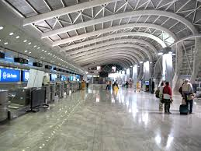
immigration | n. | moving to the other land | 
security | n. | safeguard, protection | 
baggage | n. | luggage, suitcase | 
flight | n. | lying, aviation | 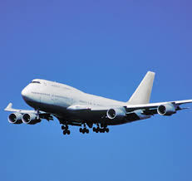
arrival | n. | Entrance, advent, coming, passenger, visitor | 
departure | n. | parting, exist | 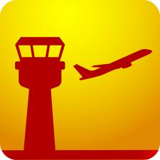
landed | v. | to park the plane | 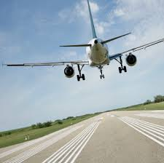

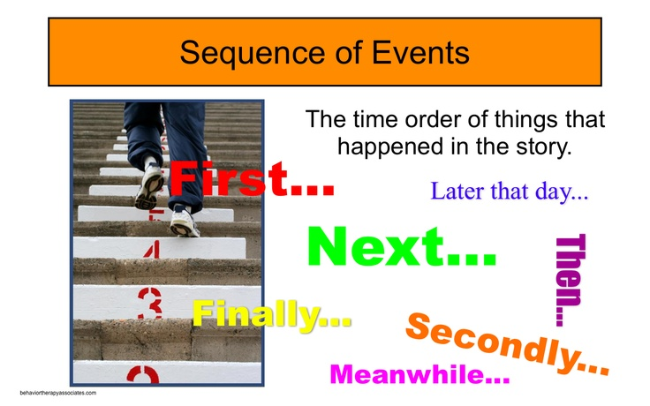
Structure: Sequence of Events

Example

